Problemas con props.match.params en componente React con TS

Property 'match' does not exist on type 'Readonly<{}> & Readonly<{ children?: ReactNode; }>'.ts(2339)

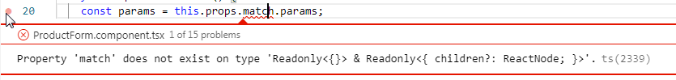

<https://stackoverflow.com/questions/50117006/reactjs-ts-property-match-does-not-exist-on-type-readonlychildrenreactno>

<https://stackoverflow.com/questions/58077580/property-match-does-not-exist-on-type-readonly-readonly-children-re>